Transformer Code Overview

1. Introduction
The Transformer is a powerful neural network architecture designed for sequence-to-sequence tasks, such as machine translation. It eliminates the need for recurrent or convolutional layers, relying instead on self-attention mechanisms.

2. Code Breakdown

2.1. Multi-Head Attention
- Functionality: Implements the multi-head attention mechanism, a crucial component of the Transformer.
- Key Functions:
  - __init__: Initializes the attention layer with linear projections for queries, keys, values, and output.
  - scaled_dot_product_attention: Computes scaled dot-product attention scores and performs attention-weighted sum.
  - split_heads and combine_heads: Splits and combines heads for parallel processing.

2.2. Position-wise Feedforward
- Functionality: Defines a position-wise feedforward layer.
- Key Functions:
  - __init__: Initializes two linear layers and a ReLU activation function.
  - forward: Performs forward pass through the feedforward layer.

2.3. Positional Encoding
- Functionality: Computes positional encodings to inject information about token positions.
- Key Functions:
  - __init__: Initializes the positional encoding matrix using sine and cosine functions.
  - forward: Adds positional encodings to the input tensor.

2.4. Encoder and Decoder Layers
- Functionality: Defines encoder and decoder layers, each comprising multi-head attention and feedforward sub-layers.
- Key Functions:
  - __init__: Initializes sub-layers, normalization, and dropout.
  - forward: Executes the forward pass through the layer.

2.5. Transformer
- Functionality: Assembles the complete Transformer model using encoder and decoder layers.
- Key Functions:
  - __init__: Initializes embedding layers, positional encoding, and multiple encoder and decoder layers.
  - generate_mask: Creates masks to hide future tokens during training.
  - forward: Connects the encoder and decoder components to produce model predictions.

3. Architectural Diagram
The Transformer architecture consists of an encoder and a decoder. Each encoder and decoder layer is composed of multi-head attention and position-wise feedforward sub-layers. The input sequence is embedded and combined with positional encodings. The model outputs logits, which are passed through a softmax layer to obtain the final predictions.
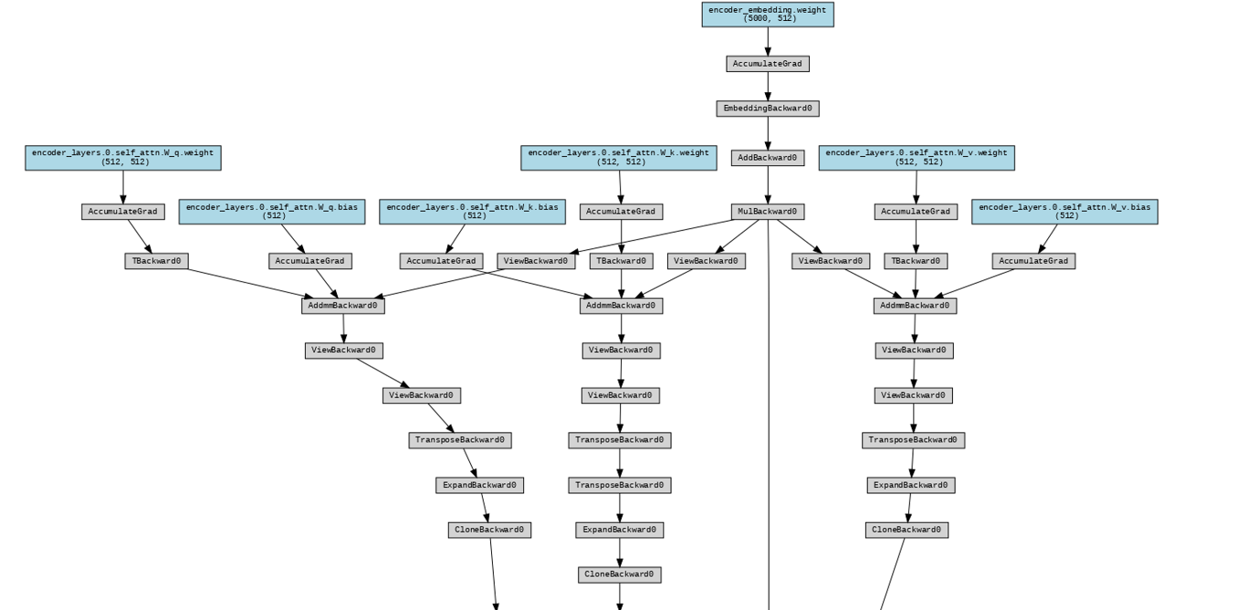

Appendix: Training and Testing

Training
- The model is trained using the Adam optimizer and cross-entropy loss.
- Training data consists of randomly generated source and target sequences.
- The training loop runs for a specified number of epochs, updating model parameters to minimize the loss.

Testing
- After training, the model can be used for inference on new sequences.
- The transformer instance takes input sequences and produces output predictions.

